Internal Curve Tangency
# Source: AI Source: Provided by: [Data Path: Persons Table -> ID Column: 1, Name_En Column: Motasem Essam] -> From: [ChatGPT] on [7/25/2026]
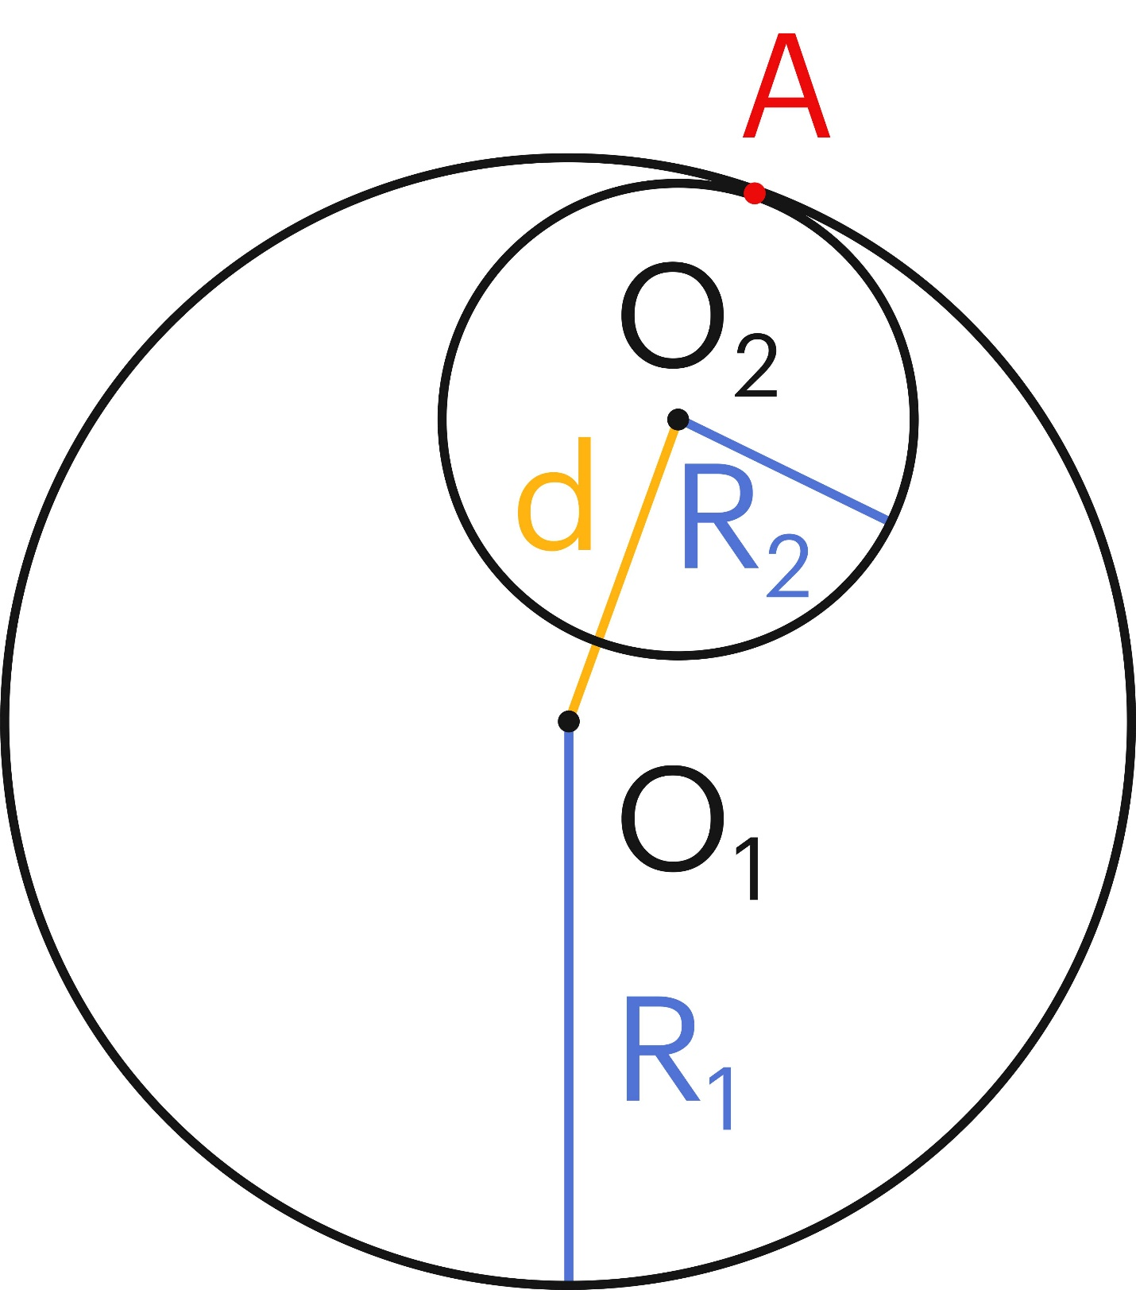
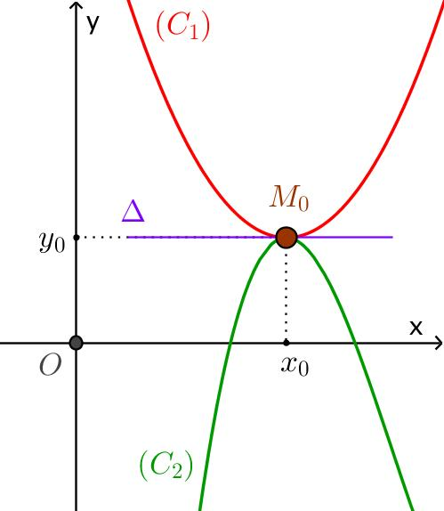
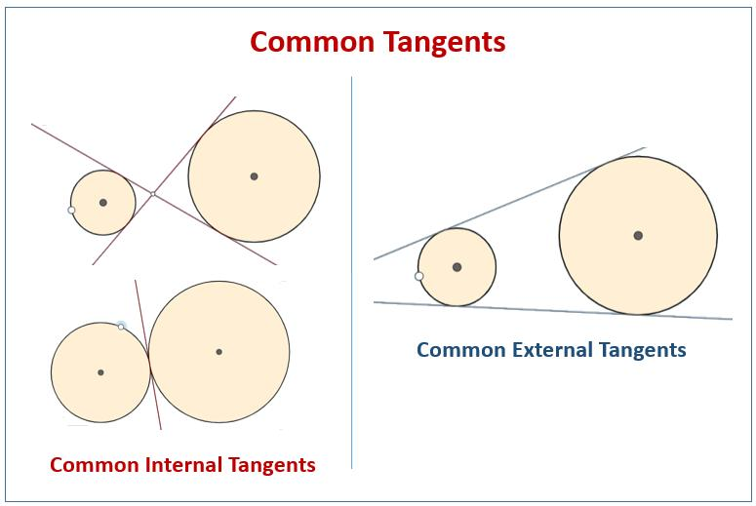

Definition
# Source: AI Source: Provided by: [Data Path: Persons Table -> ID Column: 1, Name_En Column: Motasem Essam] -> From: [ChatGPT] on [7/25/2026]
Internal Curve Tangency is a type of Curve–Curve Tangency in which two curves touch at a common point while one curve lies locally on the inner or enclosed side of the other curve.
The common point is called the point of tangency.
At the tangency point, the two curves have the same tangent line.
Unlike ordinary intersection, the curves do not cross through each other at the point of tangency.

Fundamental Concept
# Source: AI Source: Provided by: [Data Path: Persons Table -> ID Column: 1, Name_En Column: Motasem Essam] -> From: [ChatGPT] on [7/25/2026]
Let two curves be $C_{1}$and $C_{2}$, with point of tangency $T$.
For internal tangency:
$$\boxed{T∈C_{1}∩C_{2}}$$
and both curves have the same tangent direction at $T$:
$$\boxed{{\text{Tangent}}_{C_{1}}\left(T\right)={\text{Tangent}}_{C_{2}}\left(T\right)}$$
Locally, one curve lies on the inner side of the other.
This is especially clear for circles, where the smaller circle lies inside the larger circle.

Main Parts
# Source: AI Source: Provided by: [Data Path: Persons Table -> ID Column: 1, Name_En Column: Motasem Essam] -> From: [ChatGPT] on [7/25/2026]
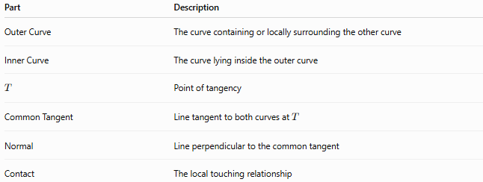
Part | Description
Outer Curve | The curve containing or locally surrounding the other curve
Inner Curve | The curve lying inside the outer curve
$$T$$ | Point of tangency
Common Tangent | Line tangent to both curves at $T$
Normal | Line perpendicular to the common tangent
Contact | The local touching relationship

Basic Diagram
# Source: AI Source: Provided by: [Data Path: Persons Table -> ID Column: 1, Name_En Column: Motasem Essam] -> From: [ChatGPT] on [7/25/2026]
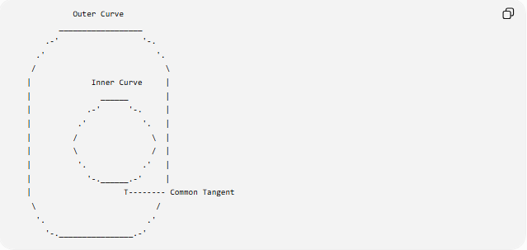
Outer Curve
__________________
.-' '-.
.' '.
/ \
| Inner Curve |
| ______ |
| .-' '-. |
| .' '. |
| / \ |
| \ / |
| '. .' |
| '-.______.-' |
| T-------- Common Tangent
\ /
'. .'
'-.________________.-'
The exact appearance depends on the curves, but at $T$:
$$\boxed{\text{both curves have the same tangent line}}$$

Defining Properties

1-Common Point
# Source: AI Source: Provided by: [Data Path: Persons Table -> ID Column: 1, Name_En Column: Motasem Essam] -> From: [ChatGPT] on [7/25/2026]
The curves meet at the tangency point:
$$\boxed{T∈C_{1}∩C_{2}}$$

2-Common Tangent
# Source: AI Source: Provided by: [Data Path: Persons Table -> ID Column: 1, Name_En Column: Motasem Essam] -> From: [ChatGPT] on [7/25/2026]
The curves have the same tangent direction at $T$:
$$\boxed{L_{1}=L_{2}}$$

3-No Local Crossing
# Source: AI Source: Provided by: [Data Path: Persons Table -> ID Column: 1, Name_En Column: Motasem Essam] -> From: [ChatGPT] on [7/25/2026]
The curves touch without crossing through one another at $T$.

4-Internal Relative Position
# Source: AI Source: Provided by: [Data Path: Persons Table -> ID Column: 1, Name_En Column: Motasem Essam] -> From: [ChatGPT] on [7/25/2026]
One curve is locally inside or enclosed by the other.
This distinguishes internal tangency from external tangency.

Tangent-Slope Condition
# Source: AI Source: Provided by: [Data Path: Persons Table -> ID Column: 1, Name_En Column: Motasem Essam] -> From: [ChatGPT] on [7/25/2026]
If the curves are written as:
$$y=f\left(x\right)$$
and:
$$y=g\left(x\right)$$
and touch at:
$$T=\left(x_{0} , y_{0}\right)$$
then the basic tangency conditions are:
$$\boxed{f\left(x_{0}\right)=g\left(x_{0}\right)}$$
and:
$$\boxed{f^{'}\left(x_{0}\right)=g^{'}\left(x_{0}\right)}$$
The first condition ensures that the curves share the point.
The second ensures that they share the tangent direction.
For internal tangency, their local relative positions additionally indicate that one curve lies on the inner side of the other.

Parametric Curves
# Source: AI Source: Provided by: [Data Path: Persons Table -> ID Column: 1, Name_En Column: Motasem Essam] -> From: [ChatGPT] on [7/25/2026]
For two parametric curves:
$$r_{1}\left(t\right)$$
and:
$$r_{2}\left(u\right)$$
internal tangency at $T$requires:
$$\boxed{r_{1}\left(t_{0}\right)=r_{2}\left(u_{0}\right)=T}$$
and:
$$\boxed{r_{1}^{'}\left(t_{0}\right)∥r_{2}^{'}\left(u_{0}\right)}$$
The tangent vectors therefore have the same or opposite direction along the common tangent line.
The internal/external distinction comes from the local arrangement of the curves, not merely from the tangent vectors.

Implicit Curves
# Source: AI Source: Provided by: [Data Path: Persons Table -> ID Column: 1, Name_En Column: Motasem Essam] -> From: [ChatGPT] on [7/25/2026]
Suppose the curves are:
$$F\left(x , y\right)=0$$
and:
$$G\left(x , y\right)=0$$
At their tangency point $T=\left(x_{0} , y_{0}\right)$:
$$F\left(x_{0} , y_{0}\right)=0 \\ G\left(x_{0} , y_{0}\right)=0$$
and their normal vectors are parallel:
$$\boxed{∇F\left(x_{0} , y_{0}\right)∥∇G\left(x_{0} , y_{0}\right)}$$
Therefore, they have the same tangent line.

Circle–Circle Internal Tangency
# Source: AI Source: Provided by: [Data Path: Persons Table -> ID Column: 1, Name_En Column: Motasem Essam] -> From: [ChatGPT] on [7/25/2026]
Circle–circle internal tangency is the most familiar special case of internal curve tangency.
Suppose:
- $R_{1}$= radius of the larger circle
- $R_{2}$= radius of the smaller circle
- $d$= distance between their centers
with:
$$R_{1}>R_{2}$$
Then internal tangency occurs when:
$$\boxed{d=R_{1}-R_{2}}$$
More generally:
$$\boxed{d=∣R_{1}-R_{2}∣}$$
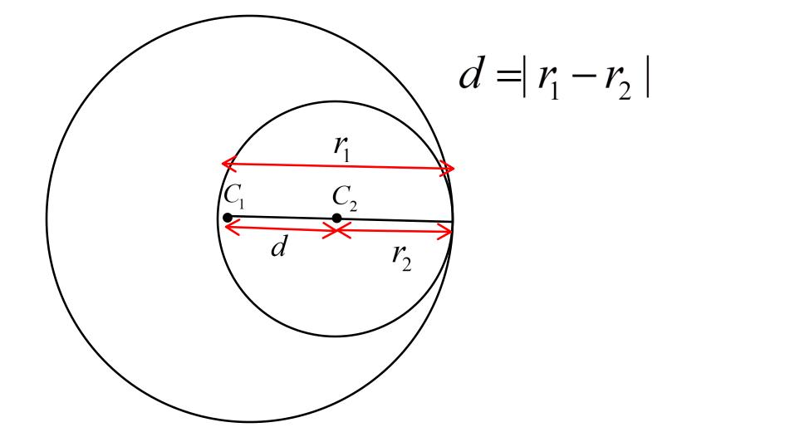
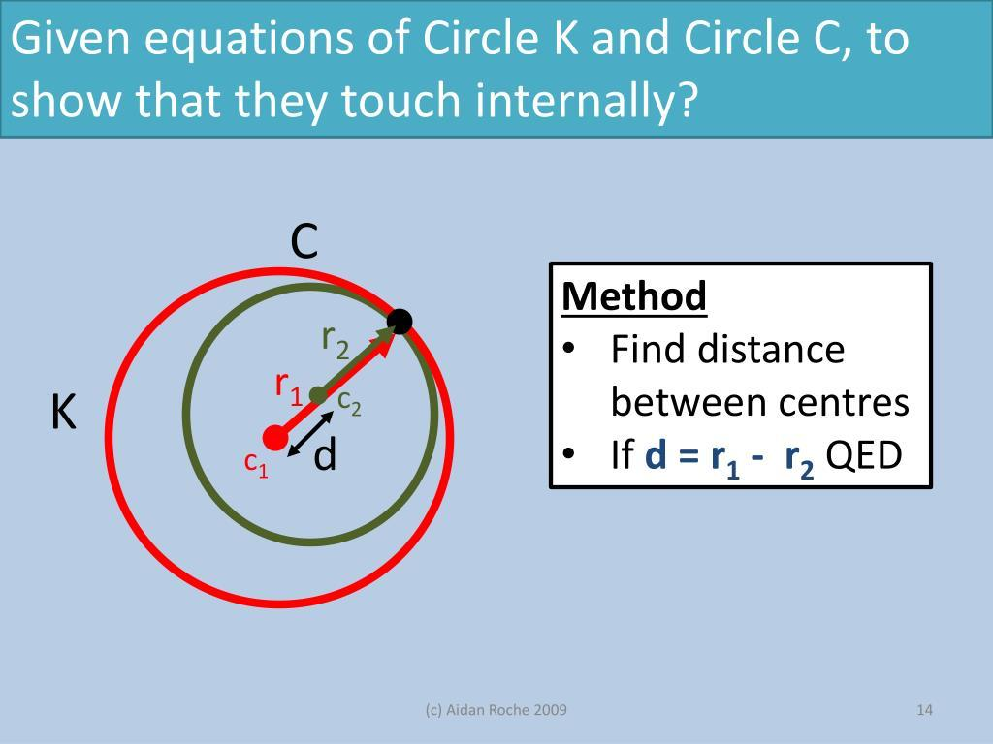

Geometry of Circle–Circle Internal Tangency
# Source: AI Source: Provided by: [Data Path: Persons Table -> ID Column: 1, Name_En Column: Motasem Essam] -> From: [ChatGPT] on [7/25/2026]
Let:
- $O_{1}$= center of larger circle
- $O_{2}$= center of smaller circle
- $T$= tangency point
Then:
$$\boxed{O_{1},O_{2},T\text{ are collinear}}$$
and:
$$O_{1}T=R_{1} \\ O_{2}T=R_{2}$$
Therefore:
$$O_{1}O_{2}+O_{2}T=O_{1}T$$
so:
$$\boxed{d+R_{2}=R_{1}}$$
and hence:
$$\boxed{d=R_{1}-R_{2}}$$

Internal vs External Curve Tangency
# Source: AI Source: Provided by: [Data Path: Persons Table -> ID Column: 1, Name_En Column: Motasem Essam] -> From: [ChatGPT] on [7/25/2026]
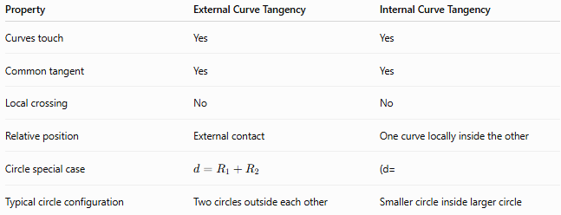
Property | External Curve Tangency | Internal Curve Tangency
Curves touch | Yes | Yes
Common tangent | Yes | Yes
Local crossing | No | No
Relative position | External contact | One curve locally inside the other
Circle special case | $$d=R_{1}+R_{2}$$ | (d=
Typical circle configuration | Two circles outside each other | Smaller circle inside larger circle
The fundamental distinction is their relative local position, not simply the existence of a common tangent.

Internal Tangency vs Intersection
# Source: AI Source: Provided by: [Data Path: Persons Table -> ID Column: 1, Name_En Column: Motasem Essam] -> From: [ChatGPT] on [7/25/2026]
Two curves can share a point without being tangent.
Ordinary Intersection
The curves cross:
$$\boxed{\text{different tangent directions}}$$
Internal Tangency
The curves touch without crossing:
$$\boxed{\text{same tangent direction}}$$
Thus, tangency is a special type of contact.

Example: Circle–Circle Internal Tangency
# Source: AI Source: Provided by: [Data Path: Persons Table -> ID Column: 1, Name_En Column: Motasem Essam] -> From: [ChatGPT] on [7/25/2026]
Suppose:
$$R_{1}=12\text{ cm}$$
and:
$$R_{2}=5\text{ cm}$$
For internal tangency:
$$d=R_{1}-R_{2} \\ d=12-5$$
Therefore:
$$\boxed{d=7\text{ cm}}$$
The centers must be $7$cm apart.

Example Using Functions
# Source: AI Source: Provided by: [Data Path: Persons Table -> ID Column: 1, Name_En Column: Motasem Essam] -> From: [ChatGPT] on [7/25/2026]
Consider two curves:
$$y=x^{2}$$
and:
$$y=2x^{2}$$
At:
$$x=0$$
both pass through:
$$T=\left(0 , 0\right)$$
Their derivatives are:
$$f^{'}\left(x\right)=2x$$
and:
$$g^{'}\left(x\right)=4x$$
so:
$$f^{'}\left(0\right)=g^{'}\left(0\right)=0$$
Both have the same tangent line:
$$\boxed{y=0}$$
However, these two parabolas illustrate an important limitation: for arbitrary curves, the labels "internal" and "external" require a meaningful local inside/outside or side-of-contact interpretation. The shared tangent and common point establish tangency, but the internal/external classification is not universally defined for every pair of open curves.
For closed curves such as circles, the classification is unambiguous.

Closed Curves
# Source: AI Source: Provided by: [Data Path: Persons Table -> ID Column: 1, Name_En Column: Motasem Essam] -> From: [ChatGPT] on [7/25/2026]
Internal tangency is most naturally defined for closed curves that enclose regions.
Examples include:
- Circles
- Ellipses
- Some closed Bézier curves
- Other simple closed curves
For two nested closed curves:
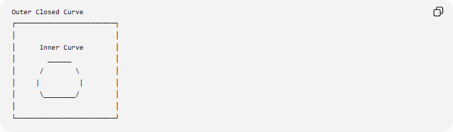
Outer Closed Curve
┌─────────────────────────┐
│ │
│ Inner Curve │
│ ______ │
│ / \ │
│ | | │
│ \________/ │
│ │
└─────────────────────────┘
Internal tangency occurs when the inner curve touches the outer curve at one point without crossing it.

Higher-Order Contact
# Source: AI Source: Provided by: [Data Path: Persons Table -> ID Column: 1, Name_En Column: Motasem Essam] -> From: [ChatGPT] on [7/25/2026]
Two curves may have the same tangent but differ in how closely they agree near the tangency point.
For example, if their first derivatives agree but their second derivatives differ, they have ordinary first-order tangency.
If higher derivatives also agree, the contact can be of higher order.
Thus:
$$\boxed{\text{Tangency does not necessarily mean identical curves}}$$
Two different curves can share:
- the same point,
- the same tangent,
- and possibly higher-order derivatives.

Important Distinction from Internal Circle Tangency
# Source: AI Source: Provided by: [Data Path: Persons Table -> ID Column: 1, Name_En Column: Motasem Essam] -> From: [ChatGPT] on [7/25/2026]
For circles:
$$\boxed{d=∣R_{1}-R_{2}∣}$$
is a complete numerical test.
For arbitrary curves, there is no universal equivalent formula involving only a pair of radii and a center distance.
Instead, tangency is determined from:
- A common point.
- A common tangent direction.
- The local relative arrangement of the curves.
Therefore:
$$\boxed{\text{Circle–Circle Internal Tangency}⊂\text{Internal Curve Tangency}}$$
as a special case.

Applications
# Source: AI Source: Provided by: [Data Path: Persons Table -> ID Column: 1, Name_En Column: Motasem Essam] -> From: [ChatGPT] on [7/25/2026]
Internal curve tangency is useful in:
- Computer graphics
- CAD and geometric modeling
- Industrial design
- Robotics
- Motion planning
- Engineering
- Optical design
- Curve fitting
- Computer-aided manufacturing
- Geometric optimization

Key Points
# Source: AI Source: Provided by: [Data Path: Persons Table -> ID Column: 1, Name_En Column: Motasem Essam] -> From: [ChatGPT] on [7/25/2026]
- Internal Curve Tangency describes two curves that touch at a common point with one curve locally inside or enclosed by the other.
- They have a common tangent line at the point of tangency.
- They do not cross through each other locally.
- For explicit curves:
$$\boxed{f\left(x_{0}\right)=g\left(x_{0}\right)}$$
and:
$$\boxed{f^{'}\left(x_{0}\right)=g^{'}\left(x_{0}\right)}$$
- For parametric curves, their tangent vectors are parallel.
- For implicit curves, their gradients are parallel.
- Internal circle–circle tangency is the standard special case:
$$\boxed{d=∣R_{1}-R_{2}∣}$$
- For arbitrary open curves, "internal" and "external" may not be intrinsically defined; the classification is most natural for closed curves with an inside and outside.

Conclusion
# Source: AI Source: Provided by: [Data Path: Persons Table -> ID Column: 1, Name_En Column: Motasem Essam] -> From: [ChatGPT] on [7/25/2026]
Internal Curve Tangency occurs when two curves share a common point and a common tangent line, while one curve lies locally on the inner side of the other without crossing it.
The general tangency conditions are:
$$\boxed{f\left(x_{0}\right)=g\left(x_{0}\right)} \\ \boxed{f^{'}\left(x_{0}\right)=g^{'}\left(x_{0}\right)}$$
For the important special case of two circles:
$$\boxed{d=∣R_{1}-R_{2}∣}$$
Therefore, internal curve tangency is a general geometric concept, while internal circle–circle tangency is its particularly well-defined and easily characterized special case.

